University of Glasgow
School of Engineering

Power Engineering 3 ENG3041

Lab 1: Single & Three Phase Systems Laboratory

Version 2

Student Name: Daniel Borkovec

Matric No: 2941124B

Introduction

Understanding single and three phase power systems with resistive, inductive and capacitive loads is fundamental to the Power Engineering 3 course. This laboratory has been designed to give you the ability to measure voltages, currents and power in a variety of single and three phase circuits. By the end of the session you will hopefully have a better understanding of the following:

- Single phase voltage, current, power factor and power relationships for resistive, capacitive and complex loads
- Three phase balanced Star connected load: phase power measurement and total supply power
- Three phase unbalanced Star connected load: total supply power measurement using the 3 wattmeter and 2 wattmeter methods

Assessment

The 3 laboratory sessions account for 10% of your final mark in Power Engineering 3. You should have with you a bound laboratory book (with graph paper). Record ALL your measured results and any subsequent calculations in your bound laboratory book during the laboratory session, also fill out the necessary results in this lab sheet (this makes it easy for me to check your results during the session).

At some point after the lab session you need to write up the results (neatly!) and complete the associated analysis/theory sections before handing in your lab books before the end of the semester.

Note that you will not be assessed during the laboratory session so please communicate freely with supervisor/demonstrators – we are here to help you obtain accurate results and to help with any questions you have relating to the associated theory.

Definitions of Power Factor (PF) & Real Power (P)

Considering the example circuit shown on figure 1 and the associated phasor diagram, Power Factor and Real Power (measured in Watts) are defined as follows:

Power Factor (PF) = CosФ where Ф is the angle between V_{S} and I_{S}

Real Power (P) = V_{S}.I_{S}.CosФ where V_{S} and I_{S} are rms values

Note: Real Power (P) and Power Factor are related to Apparent Power (S) and Reactive Power (Q) through the power triangle as shown on Figure 2
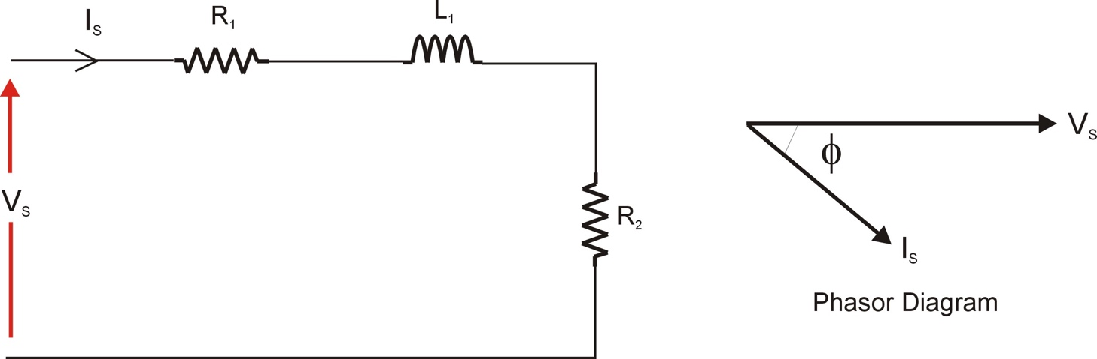

Figure 1: Example Circuit + Phasor Diagram

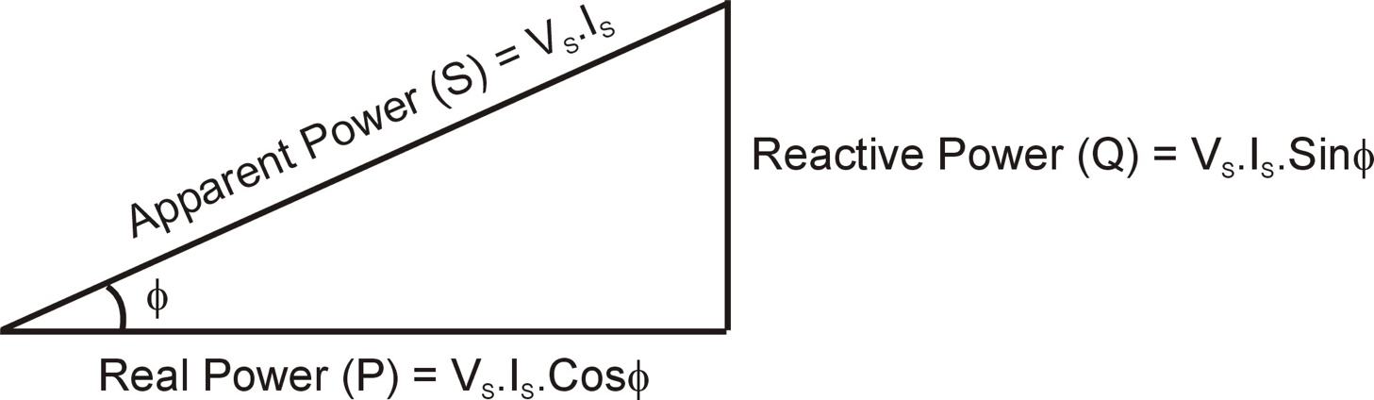

Figure 2: Power Triangle

Using the Voltech P1000+ Single Phase Power Analyser

During this laboratory session you will rely heavily on results from the Voltech P1000+ Power Analyser, an example of modern high tech electrical test equipment.

What does the Voltech Power Analyser measure?

It measures instantaneous voltage and current, and from these it calculates and displays the following:

- Voltage (rms)
- Current (rms)
- Real Power (W)
- Frequency (Hz)
- Power Factor

You can scroll the display to show all of these values by using the scroll buttons shown on figure 3. During this laboratory session you will use all of these except frequency (we assume that the supply frequency is 50Hz mains). Using these measurements you will also be able to calculate the following parameters:

- Apparent Power (VA)
- Reactive Power (VAr)

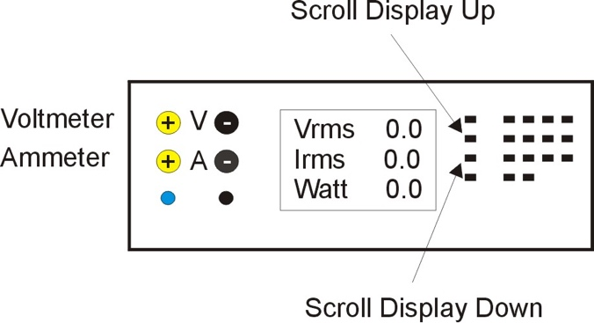

Figure 3: P1000 Scroll Buttons

The key to success in using the P1000 Power Analyser is having a good understanding of how to connect the leads to measure voltage and current. With reference to figure 3 the two voltage leads are input on the top 2 connections on the left of the P1000 (positive input to the left and negative to the right). The current leads are input on the 2 connections below these with the same polarity. Note that the polarity (+ and – inputs) of the connections is not important when we only want to measure the magnitudes of the voltage and current but it will be important when it comes to measuring power factor so make sure you understand this before proceeding – any problems then ask for (free!) assistance from lab demonstrator/supervisor. Have a look at figure 4 for polarity conventions:

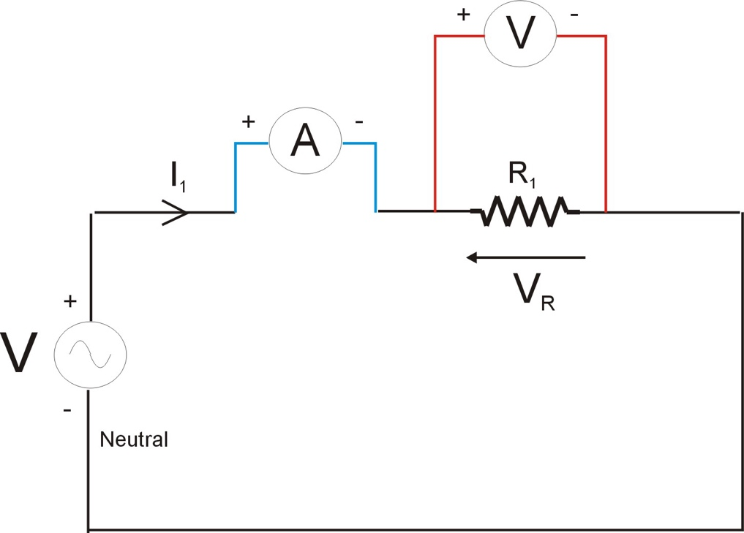

Figure 4: Voltage & Current Measurement Polarity

To help understand how to connect these voltage and current leads to the circuit to be tested consider the RC circuit shown on figure 5. The key concept to remember is that we measure current through a component and voltage across a component, therefore for example if you want to measure the current through resistor R₂ and the voltage across it then the Power Analyser would be connected as shown in figure 6.

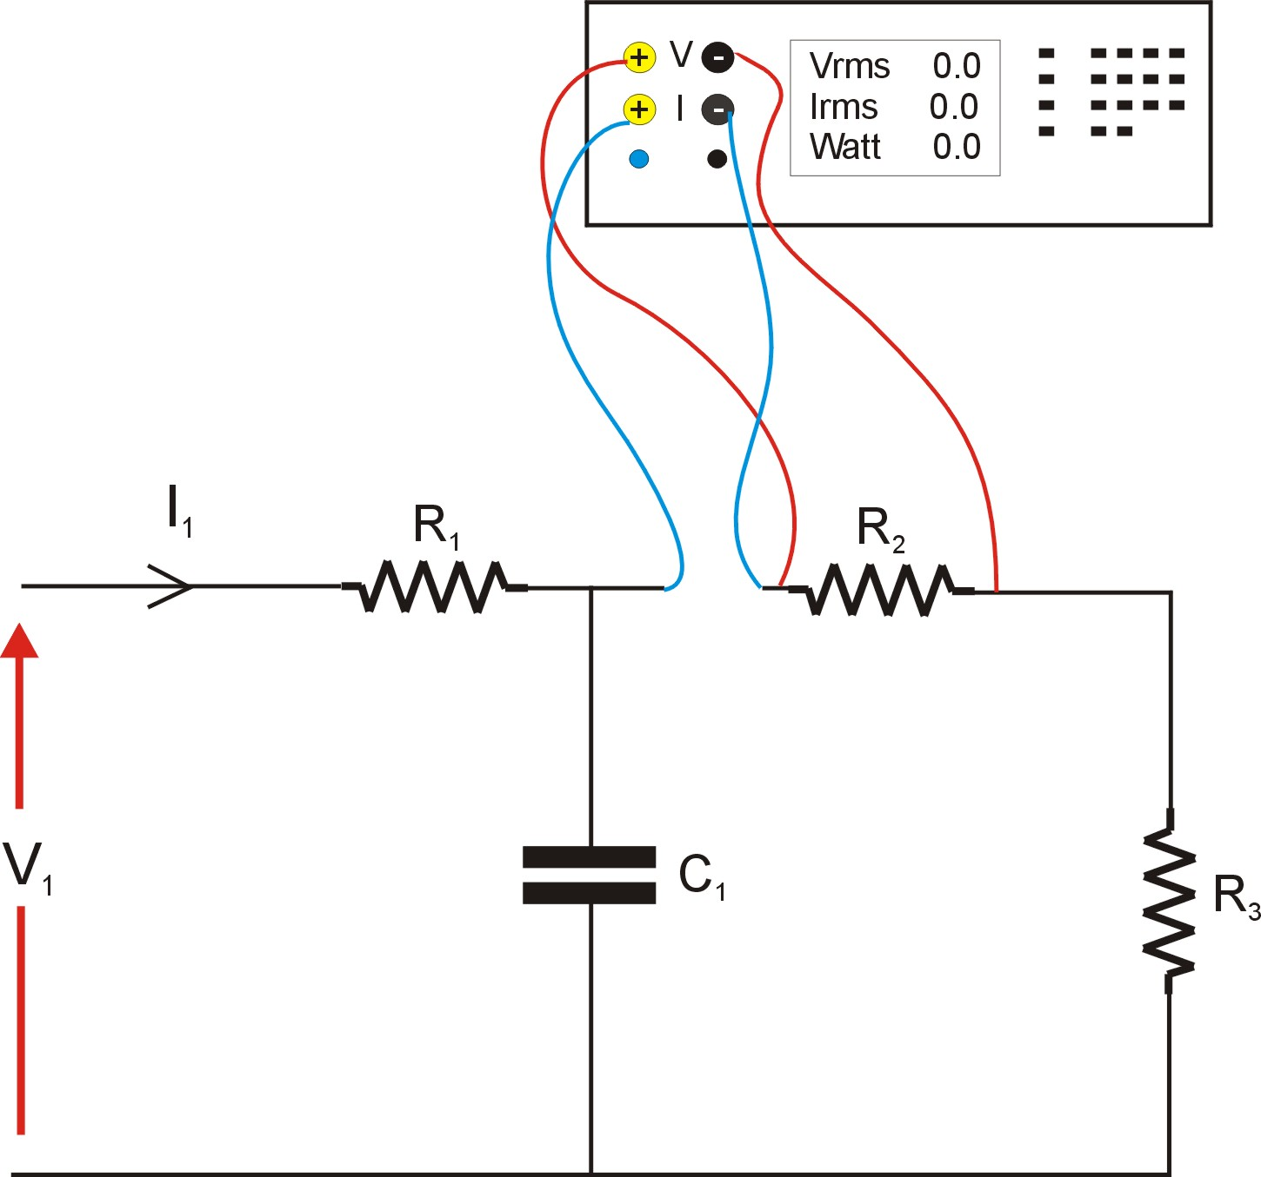
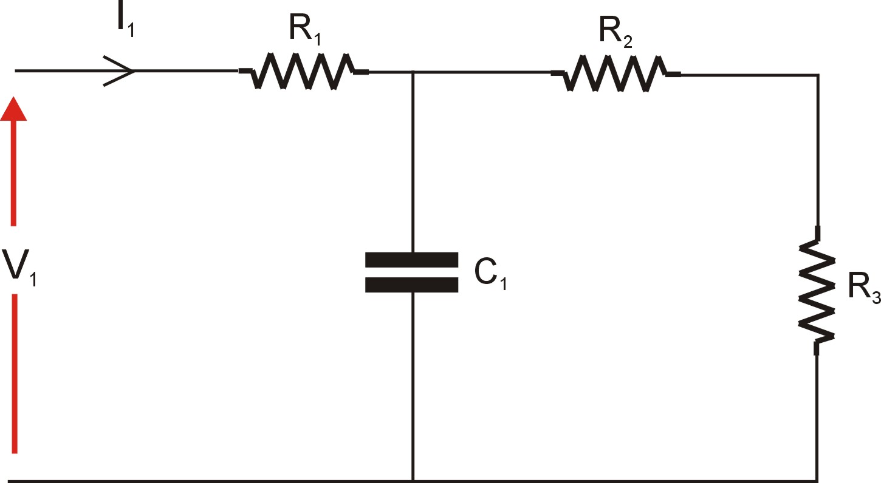
Figure 5: Simple RC Circuit

Figure 6: Using the Power Analyser
Measurement ‘Driving Test’

As ‘proof’ of your understanding indicate on the following table the required voltmeter or ammeter placement on Figure 7 (identified by its letter) to measure the following voltages and currents:

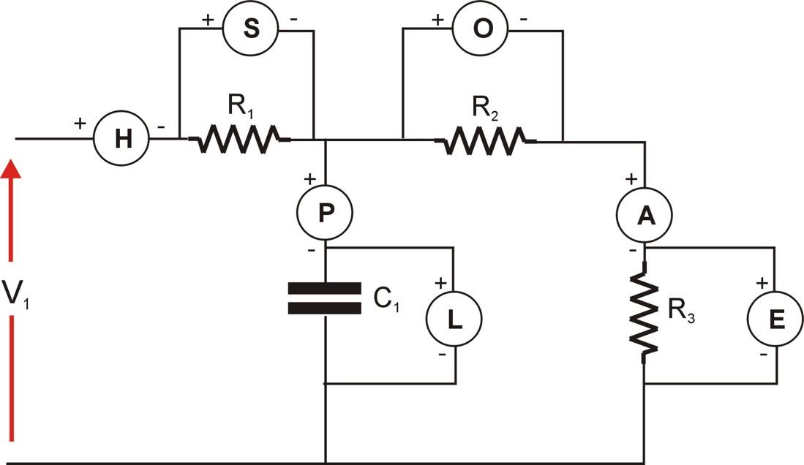

Figure 7: Example Meter Placement

 | Meter Requirement | Meter (eg P,E,A etc)
Q1 | Measure current through R1
Q2 | Measure voltage across R2
Q3 | Measure current through C1
Q4 | Measure voltage across R3

Show answer to laboratory supervisor before continuing.
Experiment 1: Single Phase Resistive Load

With the power supply turned off, select and connect a 200Ω resistor (Experiment 2 resistor box) to a single phase of the 3 phase 42V power supply as shown on figure 8.

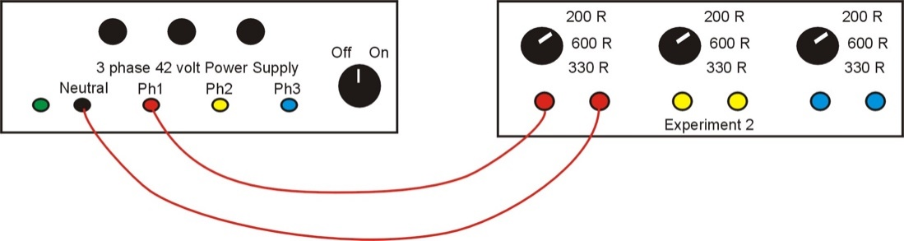

Figure 8: Resistive Load

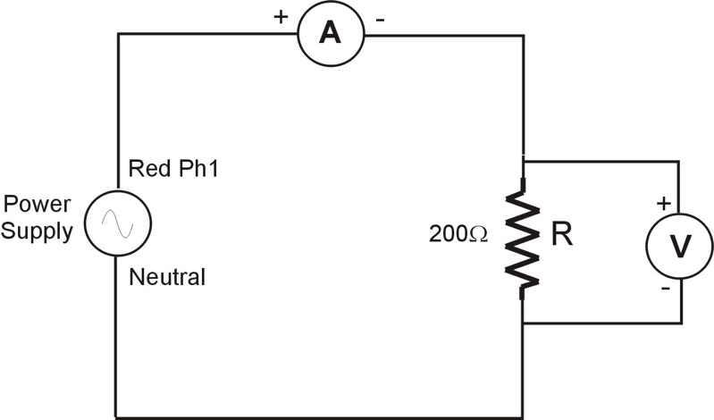

Figure 9: Wiring Diagram

Now modify the connections to include the Power Analyser measuring the resistor current and voltage. Use the wiring diagram on Figure 9 as a guide. After switching on the power supply determine the following (note: watch out for values which are expressed in milli eg milliamps).

Experimental tests:

Parameter | Value | Units
V_{R} | 25.75 | V
I_{R} | 0.127 | A
Power Factor | 1.000
Real Power (R) | 3.322 | W

Verify the Real Power Measurement by calculating the I²R power loss in the circuit:

P = R * Irmˆ2 = 200 * (0.127)ˆ2 = 3.226

Experiment 2: Single Phase Resistive + Capacitive Load

With the power supply turned off, select and connect a 100Ω resistor (Experiment 1 box) in series with a 25μF capacitor ( 3 Phase Capacitor Bank) to a single phase of the 3 phase 42V power supply as shown on figure 10. Draw a wiring diagram (similar to Figure 9) for this new load configuration including the PM1000 measuring; the current through the resistor and capacitor, and the voltage across both the resistor and the capacitor.

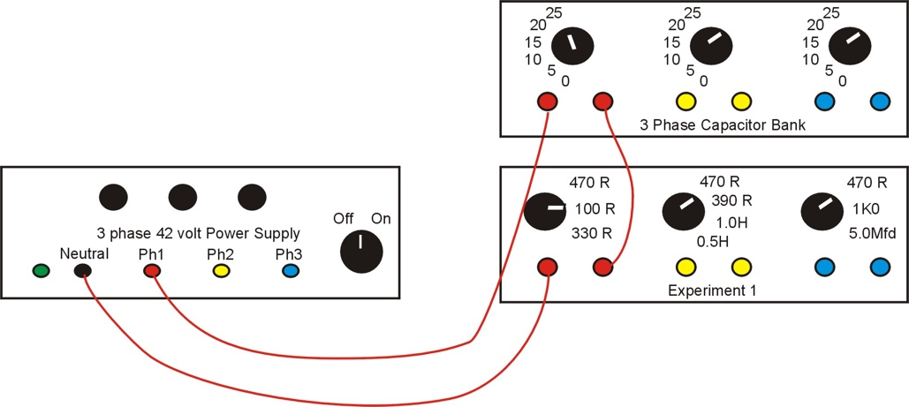

Figure 10: RC Series Load

Wiring Diagram:

Switch on the power supply and determine the following:

Experimental results:

Parameter | Value | Units
V_{ZT} | 25.82 | V
I_{ZT} | 0.157 | A
Power Factor | 0.616
Real Power | 2.505 | W

Verify the Real Power Measurement by calculating the I²R power loss in the circuit:

P = R * Irmˆ2 = 100 * (0.157)ˆ2 = 2.465 W

Three Phase Systems – Balanced Loads

The majority of long distance AC power generation and transmission uses a 3 phase system. The three phase generator voltages are equal in magnitude but are phase shifted by 120º (see figure 11). The basic idea is that we can connect three phase loads to the three phase generator in one of two ways; Star or Delta. A star connected load is shown on figure 12 and a delta connected load is shown on figure 13, with all phase and line voltages and currents shown. In our analysis we will assume that the phase voltages (V_{RN} etc) are equal in magnitude and 120º apart, and the line voltages (V_{RY} etc) are equal in magnitude and 120º apart. A Balanced load condition is when the three load impedances are equal, therefore for a Star connected load Z_{RS} = Z_{YS} = Z_{BS}, and for a Delta connected load Z_{RY} = Z_{YB} = Z_{BR}. For a balanced load the respective line currents (I_{R} etc) are equal in magnitude and 120º apart, and the load phase currents (I_{RY} etc, Delta only) likewise.

The result of this is that for a balanced 3 phase load we need only measure voltage, current, power factor and power in one phase as the power in the three phases is identical and total power is simply three times the phase power.

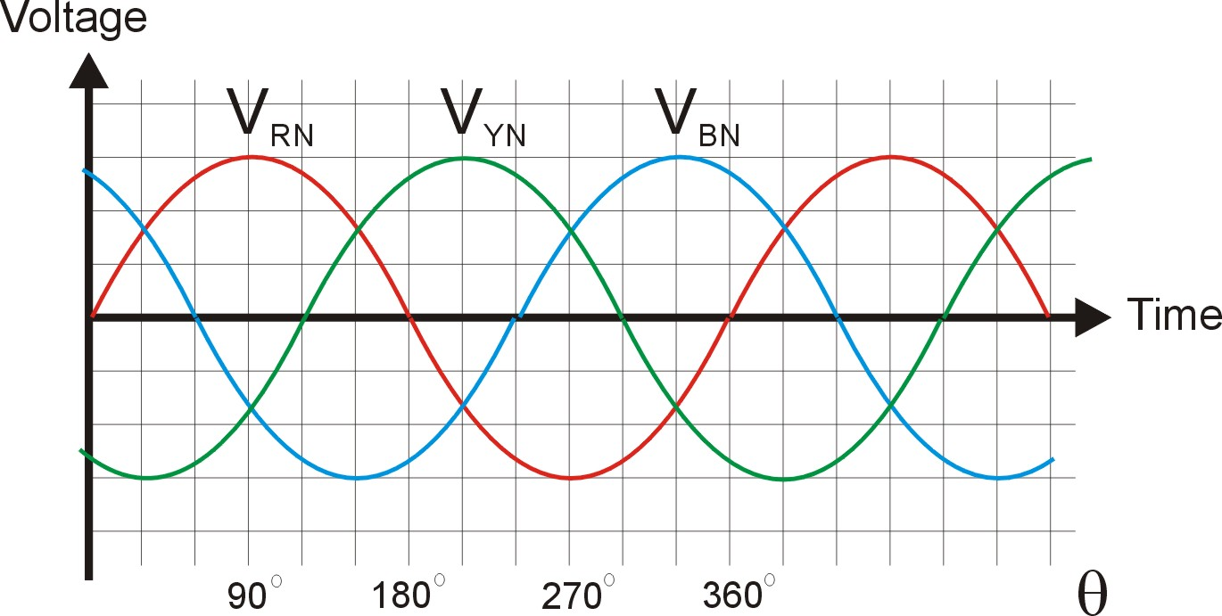

Figure 11: Three Phase Voltage Supply

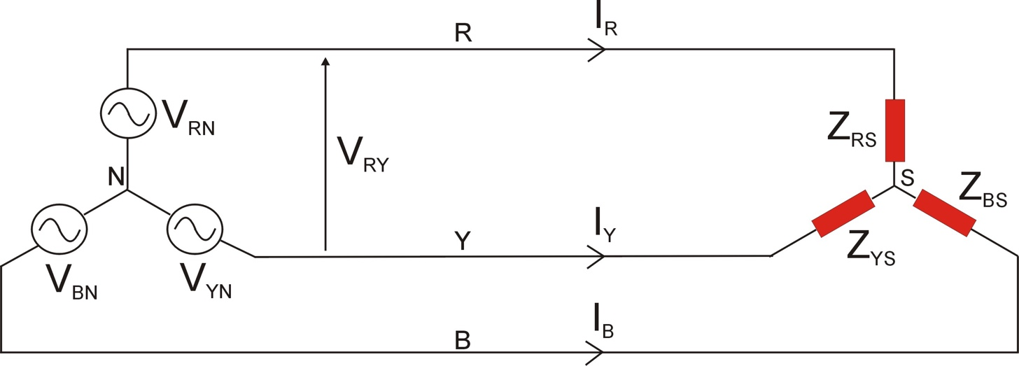

Figure 12: Star connected (balanced) load

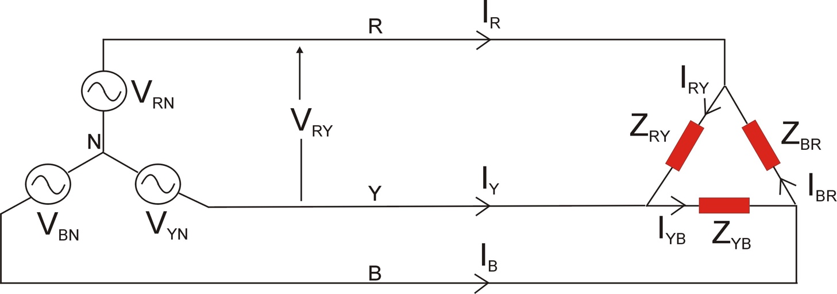

Figure 13: Delta connected (balanced) load

Parameter
Phase Voltages | V_{RN} | V_{YN} | V_{BN}
Line Voltages | V_{RY} | V_{YB} | V_{BR}
Line Currents | I_{R} | I_{Y} | I_{B}
Load Phase Currents (Delta Only) | I_{RY} | I_{YB} | I_{BR}

Experiment 3: Balanced 3 Phase Star connected load

We will now use all three outputs of the 3 phase 42Volt Power Supply. The three phase voltages are output on the red, yellow and blue terminals and the neutral point is also available on the black terminal (but not connected to the load!).

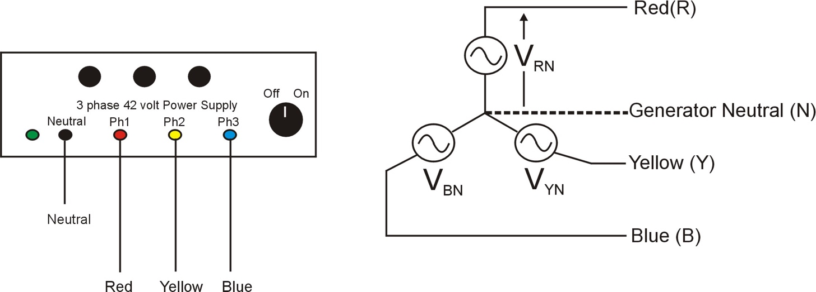

Figure 14: 3 Phase Power Supply

Now wire up (using colour coded wiring would be beneficial) a balanced Star connected load consisting of a 470Ω resistor in series with a 15μF capacitor as per figures 15.

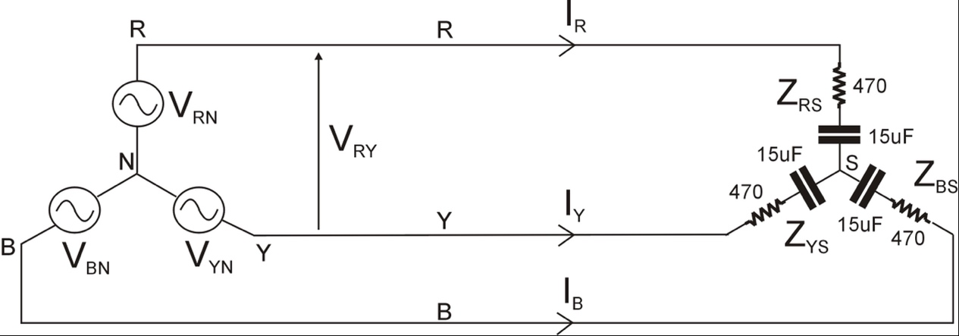

Figure 15: Star connected RC load

A useful check to see if the wiring is correct is to measure the voltage between the load star point and the generator neutral (V_{SN}). If the load is perfectly balanced then V_{SN} = 0V but due to resistor tolerances it will measure a small voltage (typically less than 0.5V for this experiment). Connect the Power Analyser voltage leads to points (S) and (N) respectively and verify the voltage is as expected:

Measured | V_{SN} | 0.401 V

In power systems the utility companies are generally interested in measuring and monitoring the Phase Power output from the three phase supply. To do this connect the Wattmeter to measure the RED Phase Voltage V_{RN} and the RED Line Current I_{R} and record the results:

Experimental results:

Parameter | Value | Units
V_{RN} | 26.31 | V
I_{R} | 0.050 | A
Power Factor | 0.911
Real Power | 1.206 | W

From this determine the total real power taken from the 3 phase supply:

Total Real Power | 3.618 | W

Verify the Real Power Measurement by calculating the TOTAL I²R power loss in the circuit:

P = 3 * IRˆ2 * R = 0.050ˆ2 * 470 * 3 = 3.525 W

Three Phase Systems – Unbalanced Loads

This is the condition where the three load impedances are no longer equal and therefore the output power from each of the three phases is now no longer equal. As a result we can no longer simply measure the power in one phase and then multiply this by 3. There are two methods to measuring power in unbalanced systems (note: these methods are also valid for balanced load conditions):

- 3 Wattmeter Method
- 2 Wattmeter Method

(the obvious advantage of the latter is that in an actual permanent monitoring setup we now require only 2 wattmeter’s instead of 3)

Experiment 4: Unbalanced 3 Phase Star connected load – 3 Wattmeter Method

Connect the unbalanced star connected circuit shown on Figure 16. In the three wattmeter method a wattmeter is placed on each of the three phases (we will have to make do with using one wattmeter in each location in turn though!).

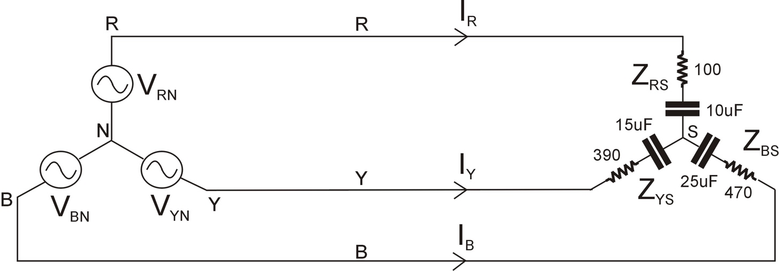

Figure 16: Star connected unbalanced RC load

Before making the actual wattmeter reading measure the voltage V_{SN}:

Measured | V_{SN} | 8.378 V

Now wire up the Power Analyser to measure V_{RN} and I_{R} and record the results:

V_{RN} |  | I_{R} |  | Real Power (P_{W1}) |  | Power Factor
(V) |  | (A) |  | (W)
23.89 |  | 0.070 |  | 0.498 |  | 0.298

Wire up the Power Analyser to measure V_{YN} and I_{Y} and record the results:

V_{YN} |  | I_{Y} |  | Real Power (P_{W2}) |  | Power Factor
(V) |  | (A) |  | (W)
34.49 |  | 0.0773 |  | 2.341 |  | 0.879

Wire up the Power Analyser to measure V_{BN} and I_{B} and record the results:

V_{BN} |  | I_{B} |  | Real Power (P_{W3}) |  | Power Factor
(V) |  | (A) |  | (W)
22.69 |  | 0.0460 |  | 1.004 |  | 0.964

The Total Real Power supplied by the three phase generator is P_{W1} + P_{W2} + P_{W3}:

Total Real Power | 3.842 | (W)

Experiment 5: Unbalanced 3 Phase Star connected load – 2 Wattmeter Method

We now want to repeat the measurement of total 3 phase power in the circuit shown on Figure 16 but this time using the 2 wattmeter method.

The connections for the two wattmeters are shown on Figure 17.

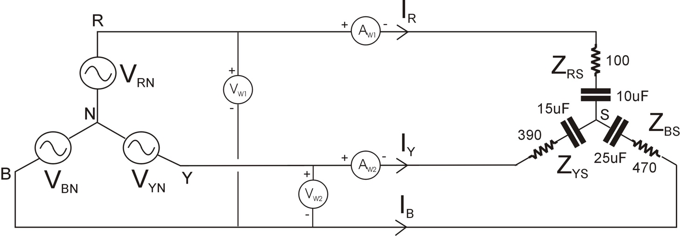

Figure 17: 2 Wattmeter Placement

Wire up the Power Analyser to measure V_{RB} and I_{R} and record the results:

V_{RB} |  | I_{R} |  | Real Power (P_{W1}) |  | Cos Φw1
(V) |  | (A) |  | (W)
45.67 |  | 0.0701 |  | 0.336 |  | 0.104

Wire up the Power Analyser to measure V_{YB} and I_{Y} and record the results:

V_{YB} |  | I_{Y} |  | Real Power (P_{W2}) |  | Cos Φw2
(V) |  | (A) |  | (W)
44.48 |  | 0.0773 |  | 3.516 |  | 0.999

The Total Real Power supplied by the three phase generator is P_{W1} + P_{W2}:

Total Real Power | 3.852 | (W)

Verify the Real Power Measurements by calculating the TOTAL I²R power loss in the circuit:

P = (IRˆ2 * R) + (IYˆ2 * R) + (IBˆ2 * R)

P = (0.070ˆ2 * 100) + (0.0773ˆ2 * 390) + (0.0460ˆ2 * 470)

P = 3.815 W

Comment on how the results from the two different methods compare.

Post Laboratory Theoretical Calculations and Analysis:

For the subsequent calculations assume a 26.8V/50Hz supply (phase) voltage.

Experiment 1:

- Calculate the supply current (I_{S}) for the given load
- Calculate the Real Power, Apparent Power and Reactive Power.
- Draw the resultant Phasor Diagram indicating the supply voltage and current
- Create a table comparing the measured and calculated results and comment.

Experiment 2:

- Calculate the supply current (I_{S}).
- Calculate the Power Factor, Real Power, Apparent Power and Reactive Power.
- Draw the resultant Phasor Diagram indicating (to scale) the supply voltage, supply current, resistor voltage and capacitor voltage.
- Create a table comparing the measured and calculated results and comment.

Experiment 3:

- Calculate the line voltage V_{RY.}
- Calculate the Red line current.
- Calculate the Power Factor of each phase.
- Calculate the per phase Real Power, Apparent Power and Reactive Power.
- Draw the resultant 3 phase Phasor Diagram indicating all phase and line voltages and the 3 line currents.

Experiment 4:

- Calculate the total 3 phase power from the supply for the unbalanced load connected in DELTA instead of star.
- Confirm these using calculations based on the 2-wattmeter method

Experiment 5:

- Calculate the total 3 phase power from the supply for the unbalanced load connected in DELTA instead of star.
- Confirm these using calculations based on the 2-wattmeter method

Dr Wenjuan Song
January 2026

